Student Name : Srujana Koripalli

Student ID- 013859651

Assignment - 277 Project Plan

1. Your team and selected application -I am working on this project individually. I have selected News Application
2. Your App name- News flash & below is the logo

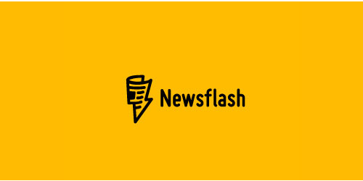

1. Design:

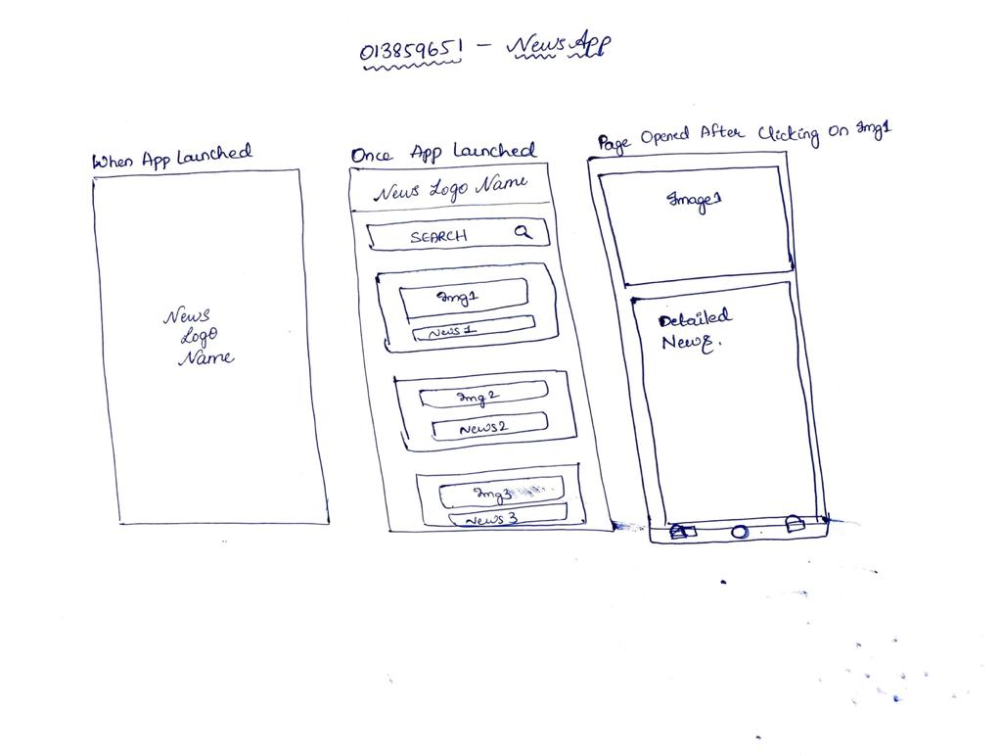

1. Focus: the logic flow and functionality :

* Functionality -I am planning on developing the display of the recent news feature by using the News API & showing it on the activity with the Recycled Card Views using MVVM architecture. For additional functionalities, when a user searches with some text, it should display the related news with that text in heading or in the content.
* Logic flow - Whenever a User clicks on the News Flash App, as soon as the News app Launches, it shows a Page with Logo for a few seconds and then it will redirect to a page which displays the recent news in the recycled card view with images and heading of the news . Once the user clicks on any information then they have to be redirected to that particular news with the detailed information on that news.